**GEOS3102: Global Energy & Resources Labs**

Dietmar Muller, Tristan Salles, Amy I’Anson

Lab Overview

|  |  |  |  |  |
| --- | --- | --- | --- | --- |
|  | **Exercises** | **Weight** | **Due Date** | **Submission** |
| Lab 1 (Week 8) | Intro to Global Petroleum Resources and iPython | 10% | Thursday May 11 @ 9am | Madsen Dropbox |
| Lab 2  (Week 9) | Badlands | 15% | Thursday May 18 @ 9am | Madsen Dropbox |
| Lab 3 (Week 10) | Seismic Reflection Surveys | 15% | Thursday May 25 @ 9am | Madsen Dropbox |
| Lab 4 (Week 11) | Well Log Analysis | 15% | Thursday June 1 @ 9am | Madsen Dropbox |
| Lab 5  (Week 12) | Arafura Basin Petroleum Systems | 15% | Thursday June 8 @ 9am | Madsen Dropbox |
| Lab 6  (Week 13) | Tectonic Subsidence and Arafura Basin Report | 30% | Thursday June 15 @ 9am | Email [amy.ianson@sydney.edu.au](mailto:amy.ianson@sydney.edu.au) |

Each week a paper copy of the exercise will be provided for you. Please write neatly and clearly, messy and illegible reports will not be marked. You are also welcome to complete the exercise in the pdf available online. Remember to attach relevant maps and data.

Exercises are shown in grey boxes, answer in the space provided or attach your answer to the lab sheet.

**Your assignment is due Thursday the following week at 9am! 10% will be deducted per day late.**

Please note: You do not need to include your script for iPython practicals unless a question states “**Include your script”** in which case you only need to include the relevant portion of your script (please do not waste paper and print the entire script).

Lab 5/6: Arafura Basin Project

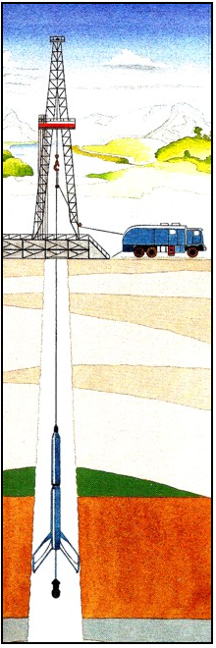For the remainder of the labs we will be investigating the Arafura Basin in the Northern Territory. In the final week you will be required to draw upon lab 5/6 in a report on the Arafura Basin.

The Arafura Basin is located on the northern margin of Australia in the Arafura Sea and extends from the onshore Northern Territory to offshore northern Australia and beyond the Australian-Indonesian border, covering approximately 200 000km2 in Australian territory.

The Arafura Basin is underexplored, and we know very little about it, only 9 wells being drilled in the 10km of sediment – it is also very old! There have been oil and gas shows but no discoveries (yet?). The Neoproterozoic to Palaeozoic Arafura Basin is underlain by the Proterozoic McArthur Basin and the Archean to Proterozoic Pine Creek Inlier, and overlain by the Mesozoic to Recent Money Shoal Basin. The structure of the Arafura Basin is dominated by the highly deformed Goulburn Graben.

The Goulburn Graben is a northwest trending asymmetric feature, over 350km long and up to 70km wide, and contains a sedimentary section in excess of 10km thick (GA, 2012).

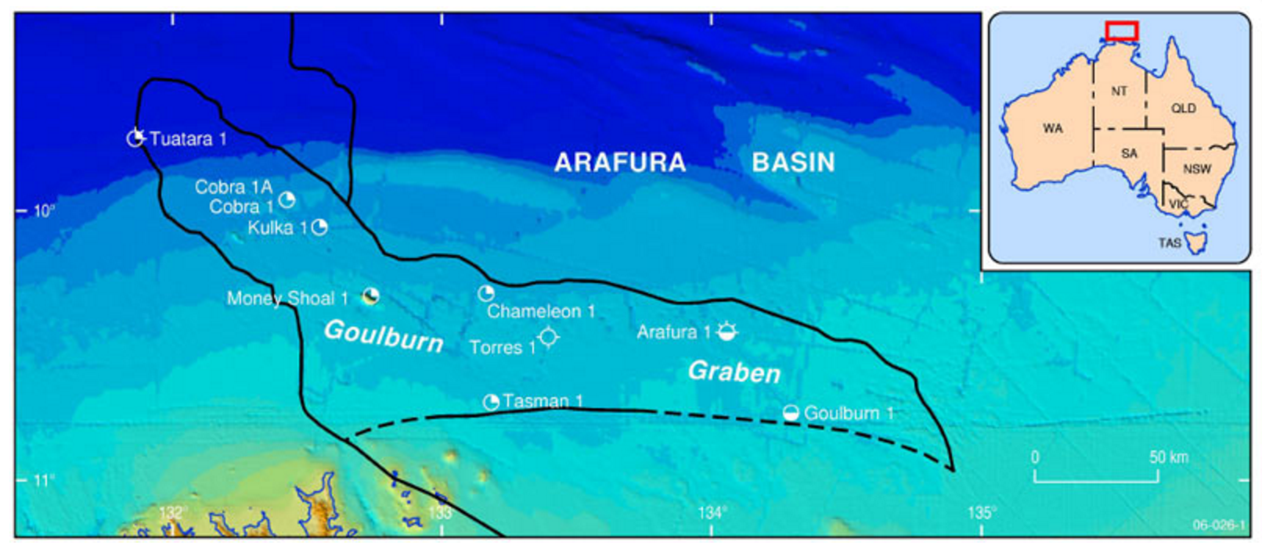

Lab 6: Backstripping Wells

Back-stripping is a geophysical analysis technique used on sedimentary rock sequences. This technique is used to quantitatively estimate the depth that the basement would be in the absence of sediment and water loading. This depth provides a measure of the unknown tectonic driving forces that are responsible for basin formation (otherwise known as tectonic subsidence or uplift). By comparing backstripped curves to theoretical curves for basin subsidence and uplift it is possible to deduce information on the basin forming mechanisms.

As a result of their porosity, sedimentary strata are compacted by overlaying sedimentary layers after deposition. Consequently, the thickness of each layer in a sedimentary sequence was larger at the time of its deposition than it is when measured in the field. In order to consider the influence of sediment compaction on the thickness and density of the stratigraphic column, the porosity must be known. Empirical studies show that the porosity of rocks decreases exponentially with depth. In general we can describe this with the relationship:

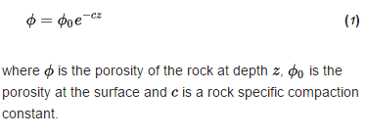

The fundamental equation in back-stripping corrects the observed stratigraphic record for the effects of sediment and water loading and changes in water depth, and is given by:

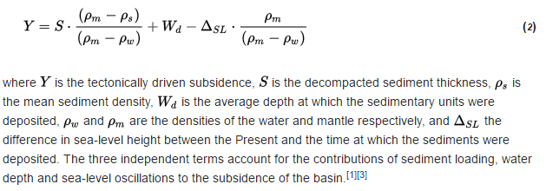

To derive equation ([**2**](https://en.wikipedia.org/wiki/Back-stripping#math_2)) one should first consider a 'loaded' column that represents a sedimentary unit accumulated over a certain geological time period, and a corresponding 'unloaded' column that represents the position of the underlying basement without the effects of the sediments. In the scenario, the pressure at the base of the loaded column, is given by:

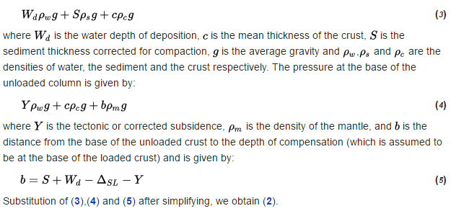

# Multi-layer case

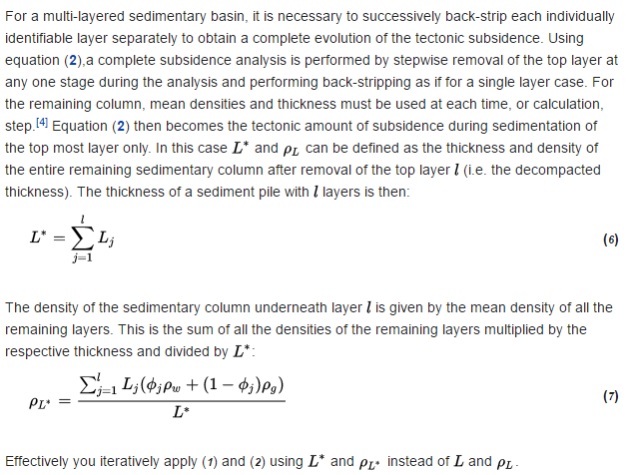

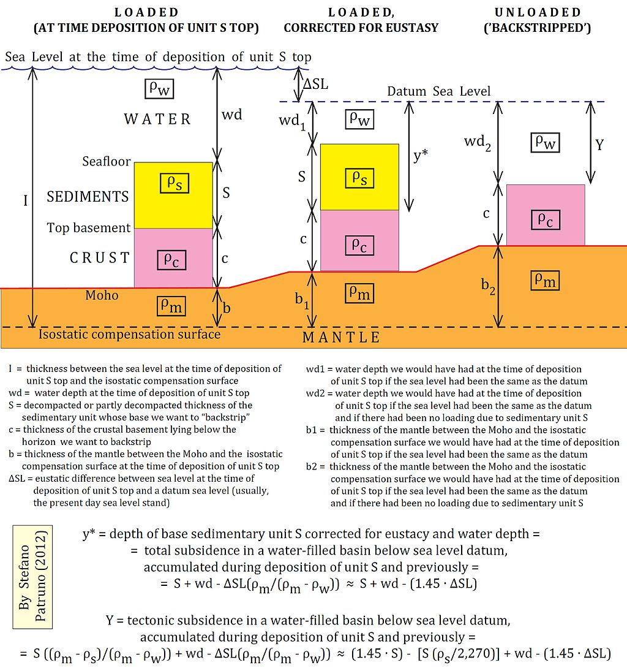

You have been provided with a matlab code that will allow us to backsrip wells. This code is based on the equations outlined above, you will need to address the theory of backstripping in your methodology section, be sure to address **why it is an iterative process.**

In the real world, Backstripping is often complicated by missing sections due to erosional unconformities as seen in your Arafura Basin well logs and the section below. Nonetheless, it is a very useful tool in basin analysis, used by industry and academia alike.

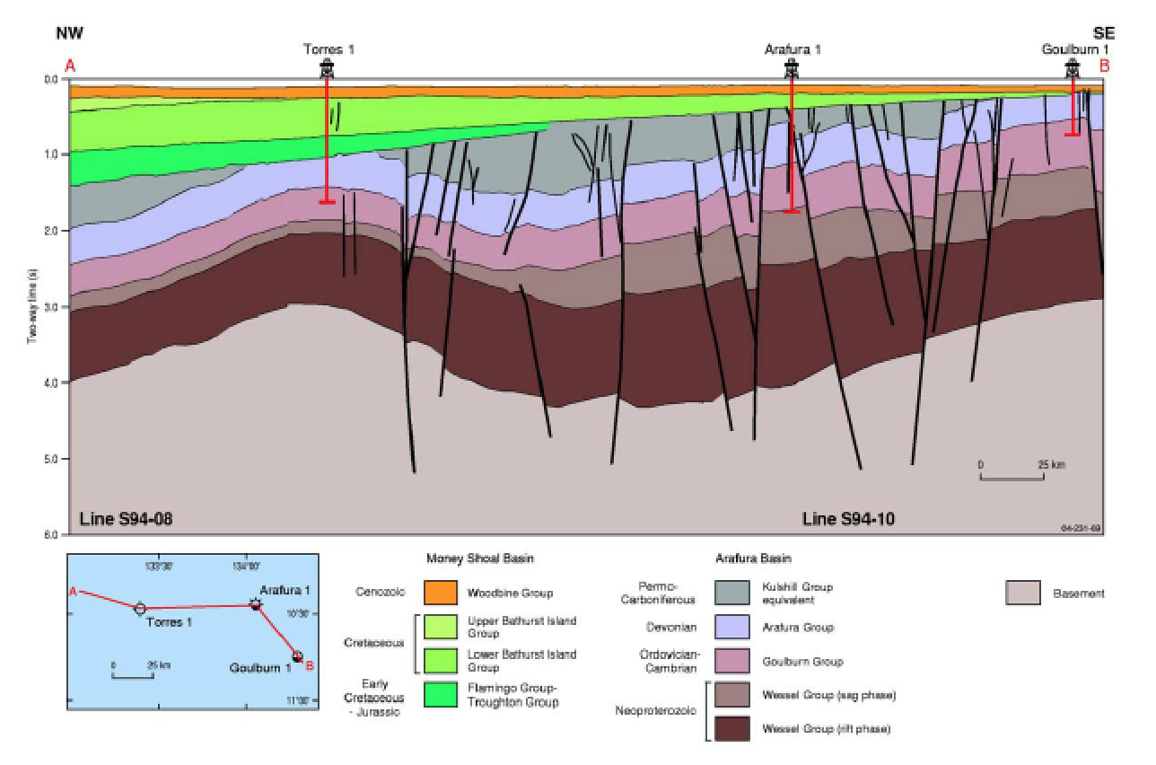

# Instructions

1. Open Matlab, or install, on your own device <https://sydney.edu.au/students/student-it/apps.html>
2. Download the lab data from blackboard, navigate to this folder (ON YOUR USB)
3. Double click on readme.txt to understand the program assumptions, structure and workflow.
4. We will start by Backstripping the well Kulka 1
5. Open the text file Kulka 1 example, you will see that it contains a series of columns specified as per the readme.txt guidelines, oldest to youngest

Top (km), base (km), age of_top (My), age of_base (My), dry density, por depth coeff, surface porosity, basin setting (1 if the basin is marine. 2 if the basin is continental)

Compare this text file to the well logs provided in Lab 5. QC the first 4 column ages, and depths. **Why doesn’t the age of the base of unit 1 equal the age of the top of unit 2?**

Porosity is given by the equation;

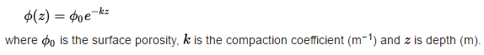

It varies by lithology as shown in the table below, these values are used for column 7,6, and 5, respectively, of your Kulka.txt file

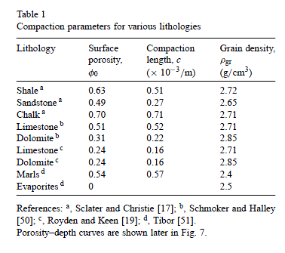

1. Run the code backstrip.m.
2. A figure window will appear where we will import the data and backstrip the well. Click parameters>read from file, you will be prompted to enter the density of water and mantle, leave as default. Navigate to the Kulka.txt file.
3. Click Solve>Decompact sediments and show the results through the menu Plot>Decompacted sediment v time. Add an appropriate title and legend. Save this plot as a jpeg or similar.
4. We will now apply the sediment load correction. Solve>sediment load correction and then plot>basement depth without water correction

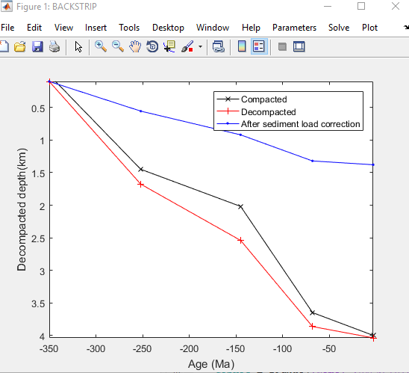

**You will now backstrip two more wells, of your own choosing, using the above methodology. Start by creating new input *parameter* files for the new well, using your favourite text editor.**

## Arafura Basin Report

You are to write a report of no more than 6 pages (including figures and references) addressing the focus questions on the Arafura Basin: **Why was Torres-1 dry?** and **Where would you drill?** Your report will be informed by the Well log analysis, Petroleum systems analysis as well as your tectonic subsidence analysis.

**Title** - The title must be concise and informative. It should state what the report is about, not simply the name of the assignment.

**Abstract** - The abstract is a precise summary of the whole report. Its function is to preview the contents of your report so that the reader can judge whether it is worth their while to read the whole report.

**Introduction** - This section presents the scope of the scientific problem. It should also provide a brief summary of the location and geology of the Arafura Basin.

**Methodology** - This section describes the scope of the data you are presenting and how they were analysed. The writing style should be direct and matter-of-fact and should not be in bullet points. Here you are to describe the data used and the methods used to analyse/interpret it. Be sure to explain why backstripping is an iterative process.

**Results** - This section presents the data and interpretations of the exercise/study. Include figures and appropriate captions. You need to present the results of your well log interpretation, your petroleum systems analysis as well as your tectonic subsidence analysis. How does the tectonic subsidence plots you created compare with documented basin history?

**Discussion** – Your discussion section should to explain the results of your study and explore the significance of your study’s findings. Therefore, you need to interpret and explain your results and **examine** **why Torres-1 was dry**.

You then need to delineate a **new well prospect** and **justify** **its location** within the Petroleum Systems Framework (What are the source rocks? What are the reservoir rocks? What seal/trap are you chasing? Does the timing work? What are the risks?). Remember to include a map showing the potential location of your exploration well.

**Reference List** – You should refer to publications that you used in your report following the Harvard, APA or Chicago System (be consistent). Marks will be deducted for poorly referenced reports as well as poorly written reports.

**Advanced Students** – you also need to include the following information in your report.

1. Calculate the volumetrics (OGIP) of your prospect, be sure to justify the values used. Assume a Boi of 0.85 and Sw of 0.35 within a 5km2 area around your well.
2. **Briefly** compare your prospect with that of Prospect X in the Northern Arafura Basin in terms of source, seal, trap, accumulation and the risk associated with each.